# Project Presentation Notes (Back End Module Project (wk5-9)

|  |  |
| --- | --- |
| name | Tim Makori |
| date | 16/03/2023 |
| Project | dsm23-0316-120 |
| github organization | <https://github.com/dsmhub1> |
| github account | <https://github.com/dsmetadata> |
| description | Multiverse - Back End Development Module 11/01/23 - 15/03/23 (wk13 - 22 of apprenticeship cohort 2) Back End Module Project (wk5-9) / Apprenticeship (wk18-22) Based on **dsm22-1030-080** **dsm22-1030-080** is the original concept/idea for the app which began to take shape around 30/10/22 (wk5 of the bootcamp & of the apprenticeship). This idea was developed further to produce a dynamic back end that formed the basis for my final project at the end of the bootcamp (wk12 of the apprenticeship). |

1. The API will fetch data from various sources/files (stored on the local machine or online).
2. The data will be available to interrogate and allow the user to perform CRUD operations (using apps like postman, thunderclient etc).
3. Once the data is read from the source, it can be copied or written to another file or database.
4. A simple front end for the app could render the data & allow the user to interact via a web page.
5. The API may allow for scrapping of data from various sources and transforming or parsing the data into various formats.
6. The components of the API, methods/functions, scripts and the structure at large will be generalized where possible for reusability and maintenance.
7. The app may eventually allow for integration with other tools or may be used as a component in another application.

Apprenticeship Statement of Intent

Cultivate & achieve the following knowledge, skills & results

* Proficiency in a number of programming & scripting languages (e.g. Java, C, Python, Javascript)
* Ability to write and apply algorithms and heuristics in programming
* An understanding of the fundamental concepts of programming
* An understanding of simulated reasoning & machine learning and to begin on a path of deeper exploration and understanding of this domain.
* Contribute to the capability to automate, simplify or optimize workflows and business process, develop tools, products and services as well as analytics, predictive and modelling capabilities.
* broadly apply knowledge and skill to various problems.
* a deeper understanding and exploration of new areas of interest.

As we started to work with data in the bootcamp & learn about the fetch API in week4, databases in wk5 & 7, express server in wk6 and my knowledge of the back end grew, It made sense for me to use the skill & knowledge acquired as well as the tech stack to develop a system for tracking what I was learning and for reference. I thought that very process of using the same skills and tools to build the app would also help me embed what I was learning.

In its current form the system looks more or less like the diagram below

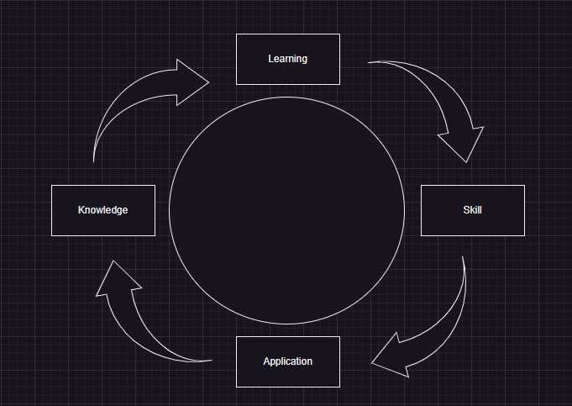

Learning a new skill and using that skill in a specific application but using the process of building the app and the application itself to expand & explore the material learned as well as a point of reference.

If a particular skill is lost, then the app can be used to reboot my learning and in a way all of these elements are kind of interlinked in a kind of bootstrap process.

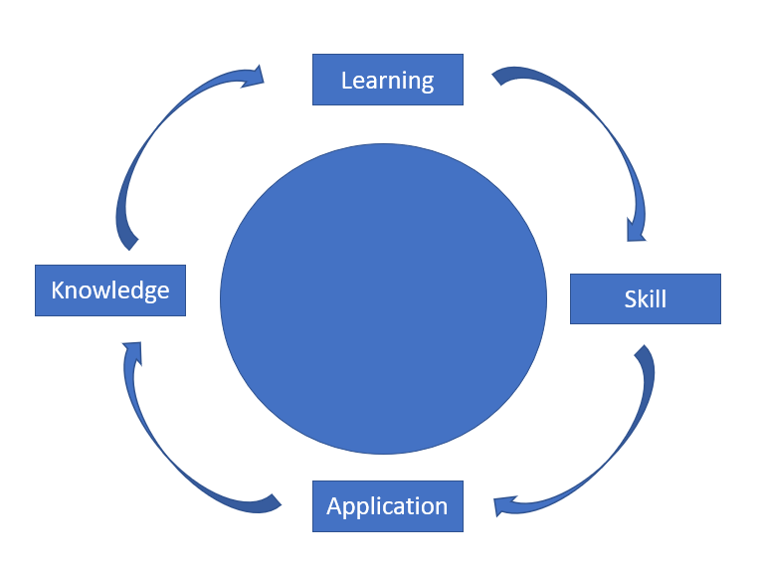

This is the first problem I wanted to solve, developing **a system that would support my learning and development.**

Personally, I find myself constantly spending lots of time searching, sifting through data and attempting to extract some kind of value in the form of an answer to a question, a solution to a problem or some insight.

I found the process to be increasingly inefficient. I began to look at the possibility of simplifying the process. I had the idea to integrate search options like sql statements, regular expressions and perhaps natural language. I became interested in and I’m currently investigating the possibility of using open ai’s whisper and gpt api or similar applications. This is the second problem I wanted the app to solve, one of **access to data or information**. This would also involve making it possible to parse & manipulate data as it is exchanged and integrated in various ways.

There was also a desire **to make some portion of my code as generalized as possible so I could re-use the code in many different scenarios**. This may also perhaps simplify the process of maintaining, updating & debugging some of my code. I would actively look at problem that a piece of code is trying to solve whether that’s a scripts, functions, methods or class or entire app, and even though the code may have worked, I went through a process of redefining the problem in a more generalized way and refactoring the code accordingly. This would sometimes require or inadvertently result in an exploring the features of a programming or scripting language such as JavaScript third party libraries in greater depth. This is the third problem I wanted to solve, for a certain portion of my code, to implement the idea of **“write once, use many.”**

I have shown the end of bootcamp app **dsm22-1030-080** to my Line Manager and will look to explore potential application areas in the business.

Here are the 3 main problems explored and a quick rundown of the results and or value.

1. **Develop a system that would support my learning and development.**

**- (short reference to slides, code, demo, illustration, video or text)**

**-**

**-**

1. **Explore the possibility of simplifying search, data exchange, integration & access to data in my API and workflow in general.**

**-**

**-**

**-**

1. **To generalize my code for reusability and maintenance (write once use many)**

**-**

**-**

**-**